Kelston Marketing: Brand Strategy

Robert Warren
Degree Program, Full Sail University
MAR632-O 01: Digital Storytelling and Branding - Online
With Professor Diane Diaz
03-27-2025

Abstract

Brand recognition is vital to any reputable business surviving in the marketplace; this brand strategy will explore branding, the brand elements, and the market research of Kelston Marketing in Southlake, Texas. This brand strategy is meant to be a tool to better the brand, reflective of research analysis. The branding elements will include the brand name, identity, business card, tagline, archetype, mission statement, story, and promotion plan. Furthermore, the market research will explore topics such as target market, product description, and competitive differentiators concerning Kelson Marketing. This is meant to formulate a strategy to congregate the brand into a cohesive identity that can make it recognizable and reputable on online and offline platforms for Kelston Marketing. Creating a strong brand of such a nature can build trust, community, recognition, personality, and loyalty and provide a framework for employee training to remain consistent in the messaging. (Jones, 2021)

Introduction
Marketing agencies in the United States are continuing to grow in number. The U.S. had 132,256 agencies in 2022, then went up to 145,936 in 2025 (Barnes Reports, 2025, p.45). That is up by 13,680 establishments. As agencies continue to pop up, it is essential to differentiate strategic branding from competitors. The brand strategy for Kelston must be to differentiate itself by honing in on the archetypes of the brand that connect with the customer. Branding does many things, from influencing purchase decisions, creating identity, helping customers remember the business, boosting advertising, and building employee support. (Decker, 2024)
“Put simply, branding is the identity of a company, and marketing includes the tactics and strategies which communicate that vision.” (Decker, 2024) This analysis will explore Kelston`s branding to reposition itself more towards its target client base of entrepreneurs and business people. By identifying the clear goal of its customers, which is financial freedom, it will better help define the positioning of the brand. The public must view Kelston as a brand that can lead them to success through trust. As the archetype of the brand reflects royalty, with a subtype of explorer, Kelston can position itself in a clear way to target those from Gen Z to Millennials, as reflected in the Kelston social media platforms. This analysis based on research will work to overall improve Kelston’s branding.
Kelston Marketing: Brand Strategy Elements

Branding Components
“Brand is the holistic sum of customers’ experiences, composed of visual, tonal, and behavioral brand components, many of which are shaped by interaction design.”– Kate Kaplan (Boicheva, 2023)

Brand Name
“Kelston” can refer to a few things. It can refer to the 1958 Kelston School for the Deaf in New Zealand (History of Elston - Ko Taku Reo, n.d.), the village of Kelston in the United Kingdom, or Kelston Roundhill an ancient burrow which “it is believed that the word Kelston translates as Hill of the Celts.” (Village, n.d.) As far as the Kelston village goes, “Kelston was part of the hundred of Bath Forum. The name of the village was recorded as Calveston in 1178. The familiar -ton ending indicates farmstead or estate. The first part of the name may mean; a belonging to a person, possibly Celf or Caelf.” (Village, n.d.)
Analyzing what people can take away from this and how the brand can position itself in a way that reflects its historical identity is key. Kelston can be seen as a way to give a voice to voiceless companies to make them be heard and give them a sense of belonging. As far as the name belonging to a person, that can be seen how the name of Kelston in Southlake, Texas, belongs to Stephanie Cross, an award-winning brand marketer. (About Kelston Marketing | Dallas Marketing and Branding Studio — Kelston | Marketing and Branding Studio in Southlake, TX, n.d.-c) Further looking into the name being reflective of history in New Zealand along with history in the U.K. this brand can be indicative of travel as these two places reflect as travel hotspots.
Looking into the Kelston brand and how it positions itself across different platforms it does need more of a consistency in its messaging in the brand name. On the website as well as email its “Kelston Marketing”, on Instagram/Facebook it`s “Kelston Creative” and on LinkedIn it`s “Kelston”. It can be tricky to position the brand as it is a creative studio offering branding, and marketing services. As Kelston is primarily focused on services it would be best to have a clear message of “Kelston Marketing”. Focusing on the marketing aspect makes it more clear what Kelston does. Brand consistency is important to increase customer trust and loyalty, differentiate from competition, and build authority in the brand. (Everything You Need to Know About Brand Consistency | Mailchimp, n.d.)
According to Alexandra Watkins of Eat My Words brand names have a formula to stick. They follow the method of S.M.I.L.E. and avoid S.C.R.A.T.C.H. “SMILE: The 5 Qualities of a Super-Sticky Name are: Suggestive—evokes something about your brand, Memorable—makes a familiar association, Imagery—aids memory through evocative visuals, Legs—lends itself to a theme for extended mileage, and Emotional—moves people.” (Carol Cox, 2014) Avoiding S.C.R.A.T.C.H. which is: “SCRATCH: The 7 Deal Breakers: Spelling challenged—looks like a typo, Copycat—resembles competitors’ names, Restrictive—limits future growth, Annoying—seems forced, frustrates customers, Tame—feels flat, descriptive, uninspired, Curse of knowledge—speaks only to insiders, Hard to pronounce—confuses customers” (Carol Cox, 2014)
Looking into the name Kelston Marketing it makes clear its identity which is marketing. (This is why it is best to stay with this and not Kelston Creative or just Kelston). It is easy to say Kelston. Customers are not aware from just the brand name that it is based in Southlake or DFW which is a downside. Kelston does have a harder time connecting just because people may not have an imagery to connect with Kelston. It is not like saying house where you think of a home. The upside to this is there is less competition with Kelston as it is less familiar but up to the brand to create that imagery and identity.
- Brand Identity
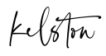
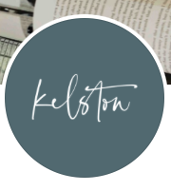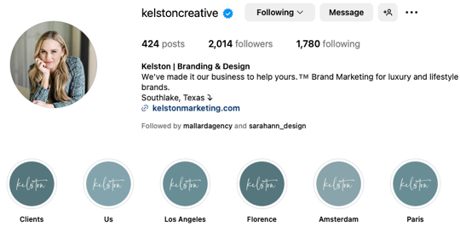
Looking at the logo the first thing that pops out as having an issue right from the get-go
again is consistency. Facebook has a shade of shamrock green, Paradiso, or the hex color number being #4A787D from color dropping the color. The text appears white. LinkedIn lines up with this. The website pops open Kelston in all black text with a white background for the header. This works as it almost lines up and is based off the background. Then looking on the website tab on the page it is just the letter “K” with that green again. This almost remains consistent but ventures a bit of a new path with a “K” logo instead of the full name. Then on the Instagram a Stephanie Cross image is used instead of a logo. It would be better to just keep everything consistent. When the customer is looking at the brand too many mixed messages, even small ones can confuse the customer. Using the “K” instead of the Kelston name can actually play a big difference. “Brand Dilution: Multiple logos can dilute the brand identity by creating confusion among customers. It becomes challenging to establish a consistent and recognizable brand image.” (Hashemi, 2023)
Using cursive writing for the brands logo is a smart move to display elegance and royalty which match the brands archetype. “Traditionally, cursive fonts have been synonymous with heritage, elegance, and sophistication. Brands like Coca-Cola and Ford used cursive scripts to convey a sense of nostalgia, tradition, and timeless charm.” (Soap Guides: From Cursive to Sans Serif: A Look at Branding Trends, n.d.) The only risk with cursive is that much of GenZ is struggling to read cursive which can make it difficult to get that brand imagery across. (Brands Keep Dumping Their Script Logos. Which Brand Will Be Next?, 2023) Overall though it is a nice charm to reflect the elegance of the brand matching much of the royal look that reflects in Kelston`s social, such as its Instagram, with that of wines, upscale interiors of homes, travel and hotels.
Looking into the brand colors we can analyze the green as primitive like “our primitive relationship with the first creation of the world – nature. Considered the key color that represents purity, health, and freshness, green has been traditionally associated with brands that encourage growth, vitality, and productivity (think Starbucks and EverNote!).” (Color Psychology, 2025) Using green shows signs of adventure, travel, relaxation, jungles and wilderness. Green can also be reflective as growth such as a flower blooming from the grassy abyss, freshness, ecofriendly, or sincere. As this green color, aligns with a blueish- green or teal feel, it also mixes with some blue meanings. This can be reflected as personal, calm, peaceful, warm, personal, and sympathetic. Then take that boldness of the black mixed with the elegance of the white. (Color Psychology, 2025) Think a bride walking down the aisle commonly as white. This is very good for reflecting a bold, understanding brand that carries a royal archetype with a subtype of adventurous. So the colors are spot on.
- Business Card
Front Back
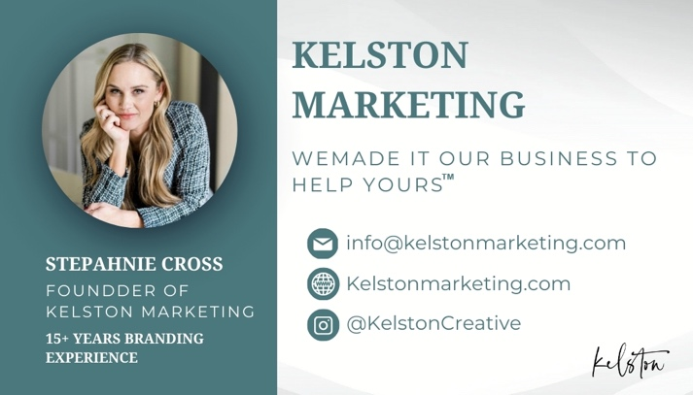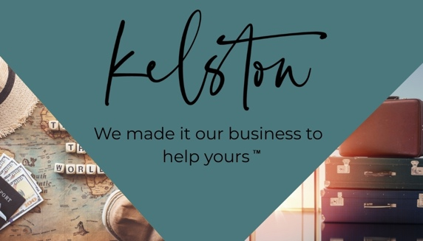
As there is no business card for Kelston readily available attached above is a business
card made in an attempt to capture the essence of the brands marking material. The key is keeping consistency in color and theme. One thing that would help the business is adding a phone number and address online. There is none located anywhere on the website, Google Business, or social media. On the card is Stephanie Cross, as she is the owner of the brand and with so much experience will help the brand stand out.
Added is the Kelston logo on the back/corner of the front and the tagline is on both sides. The front captures the luxury archetype and the back captures the explorer (or traveler) sub archetype. The color is the same color number as the website. This card includes the main contact information for the brand as well as the Instagram as that is the biggest presence in the social media platforms. This is meant to be a starting point for the business in marketing with a business card. Going deeper it would be good to later add NFC capability to one card always kept with the main salespeople of the brand. The reason for NFC cards would be to tap information into peoples phones that can quickly lead them to the main sites of the brand. As NFC is still a newer form of communication it can be effective to impress before they grow and become more common.
“An NFC business card is a smart business card that allows you to exchange contact information using near-field communication (NFC) technology. Unlike paper cards, you don’t hand out an NFC card whenever you meet a new connection. Instead, people can tap the card on their phones to receive your contact information. NFC business cards offer an innovative, digital way to share contact details. The NFC business card market is set to grow at a CAGR of 9.5% through 2031, indicating the fast adoption of NFC business cards.” (Gupta, 2024) Another addition down the road to be considered would be adding a QR Code to the card to more quickly lead customers to the Kelston Marketing website.
- Tagline
An effective tagline is clear of three elements: mission, promise and brand. (Chartrand, 2023) Kelston`s tagline is: “We made it our business to help yours.™ Brand Marketing for Businesses That Want to Feel Liberated” (Kelston | Marketing and Branding Studio in Southlake, TX, n.d.) This is an effective tagline as it makes clear the benefits to the consumer as it helps business feel liberated. This is the promise. How does it do that? Through the mission: helping businesses with brand marketing.
Although it is really two things Kelson helps with: branding AND marketing this is an effective statement showing a clear focus on the brand marketing. When you really dig into the site for Kelston under services, there is brand development services, creative and marketing. It would almost be a better tagline to say: “We made it our business to help yours.™ BRANDING AND MARKETING for Businesses That Want to Feel Liberated” as the creative really can fall under marketing as well. Also digging further on the website under being welcomed in Kelston you are greeted with the mission statement that says, “Kelston is a creative studio specializing in branding, web design, and copywriting for courageous companies and entrepreneurs.” (Kelston | Marketing and Branding Studio in Southlake, TX, n.d.) Entrepreneurs is not even mentioned in the tagline. Under this notion the tagline should really be: “We made it our business to help yours.™ BRANDING AND MARKETING for Businesses AND ENTREPRENUERS That Want to Feel Liberated” This covers everything the business stands for.
Consistency is something that needs to be evaluated with the tagline. On Instagram the tagline is: “We've made it our business to help yours.™️ Brand Marketing for luxury and lifestyle brands.” Facebook is: “Kelston is a creative studio based in Southlake, TX specializing in brand development and website design for courageous companies and entrepreneurs.” LinkedIn is just “We've made it our business to help yours. ™” So the tagline just needs to line up no matter which page you visit with a clear vision, audience and purpose.

Brand Messaging

Brand Archetype
The purpose of a brand archetype is “Archetypes are distinct from personas (a word
derived from Latin which means ‘mask’), which represents the image we wish to project to the outside world.” (Brand Archetypes, n.d.) When taking a brand quiz from Kayeputnam.com Kelston identified with the royalty archetype. This type is reflective of success and is authoritative. Jennifer Lopez, M. Tyrell from Game of Thrones or even Duchess Katherine are reflective of this archetype. Brands falling under this would be Louis Vuitton, Rollex or Royes Royce. (Royalty Brand Archetype | Psychology-Driven Brand Strategy, 2024b)
This is reflective of Kelston as it aims to lead other businesses to success with a friendly yet authoritative tone. “We create aspirational brands that generate lasting consumer value. You'll love working with us too – we're a passionate team committed to excellence.” (Kelston | Marketing and Branding Studio in Southlake, TX, n.d.) Also, much of the social media is indicative of wealth in technology as well as knowledge with cell phones, laptops, expensive camera setups, and books. The sub archetype could be argued to be of an explorer with lots of travel posts, green colors and derivative points from the brand name tied to history mentioned earlier.
- Mission Statement
The mission statement is: “Kelston is a creative studio specializing in branding, web
design, and copywriting for courageous companies and entrepreneurs.” What works here is the statement is informative and brief. (Peek, 2024) It would be good to incorporate the purpose: TO FEEL LIBERATED at the end. The products offered are very clear. Great statement. Just missing the purpose. Also saying it is a creative studio could be confusing to some consumers so it may just be best to say KELSTON MARKETING is… and run with that. This helps get across the brand as a marketing brand that as mentioned later specializes in branding.
- Brand Story
Kelston is a brand that helps businesses and entrepreneurs feel liberated. Created by
Stephanie Cross, the Kelston brand showcases predominately female staff members in their Instagram stories “Us” section. They mention also supporting local businesses and shows mostly women in Kelston`s social media. There is a sense of female empowerment. The brand story gives the point of view from a failing business person getting help from a woman (that of Stephanie Cross,) which helps take their brand to success. It showcases the feeling of being lost as many business people do and shows why the Kelston brand is different by being that of female empowerment. It tells the story through the perception of a customer of Kelston seeking the brand because of that empowerment and lostness. It tells it imagery of adventure and luxury. This is the brand story you can see HERE.
- Promotion Plan
The promotion plan is to start by getting more of a presence on social media. To do
this it would be best to use a scheduler like social champ at only $8 monthly, or schedule directly within the apps, and be focused on improving specific channels since it is a small team. Instagram where the business is getting the most views would be best to target first. As this is a primary spot where younger generations live it would best to use more Instagram Reels and Carousels. Investing time to engage. Using Meta Suite we would look into the best times to post based off the most active times of the audience. We would also post more behind the scenes content for our true biggest fans on our stories.
Next we would separate the Facebook posting from Instagram as it seems much of the material is being cross-posted. Still we would look at this content and schedule it out. On here we would target a little older generation, as most entrepreneurs in 2025 live in two sections 51% ages 55 and up, 43% 35-54 years of age and 6% in 34 and under. (Nicholaisen, n.d.) We would take a look how to target entrepreneurship vs. that of businesses, and what it means to be a entrepreneur instead of a business. After that we would also look about adding a blog to the website to improve SEO as there is none currently and how to use tags, Meta descriptions, backlinking and alt tags to improve authority. Once we accomplished those mediums we would dig further but it is better to target a focused few and be successful than be spread out and reach no one.
- Market Research
- Target Market
The target market for Kelston is any luxury/lifestyle brand entrepreneurs/businesses
at an age between 20-55. Most of the social media as of now is geared toward a younger generation (hence the laptops/cell photos/ and younger models) with opportunity to also target some of the older successful business people on Facebook. Keeping the brand in a moderate way however that we do not lose the GenZ or Millennials of business. Kelston is more luxury targeting a higher class of wealth with a traveling soul. Those who may be looking to get away from their business on vacations when it reaches success.
- Product Description
The product Kelston is providing the service of branding and marketing. It is
consulting. Kelston lists its products very clearly on the websites into three main categories: brand development, creative and marketing. Sub products can include: “Strategy,
Re-Branding, Copywriting, Tone of Voice, Logo Design, Business Naming, Brand Style Guidelines, Website Design, Graphic Design, Brand Programming, Signage, Sales Assets, Strategy, Organic Social Media, Ideation, and Search Engine Optimization.” (Kelston | Marketing and Branding Studio in Southlake, TX, n.d.-c) Also did you notice what is not in there? PPC or Paid Advertising. This is not the focus of Kelston. Direct competitors would be Mallard Agency and Ronkot as they both have DFW locations and offer branding services. Indirect competitors would be RiseLocal based in DFW, a marketing agency but does not offer branding services.
- Competitive Differentiators
What separates Kelston is the primary focus on branding and willingness to work with not only DFW brands but also national brands. Kelston is more female focused and has more of a good people push on their website. (As you can see in many of the quotes). The explorer side that Kelston takes on is not explored by competitors. Kelston has a very good website in comparison to that of some of the competitors with more of a creative take, with more images and color, but lacks a blog. The name of the brand is good for easily finding Kelston. Once the brand develops more consistency and deeper presence this brand should be much more developed and recognizable over time.

References
Jones, K. (2021, March 24). Council Post: The importance of branding in business. Forbes. https://www.forbes.com/councils/forbesagencycouncil/2021/03/24/the-importance-of-branding-in-business/
Barnes Reports: Marketing Consulting Services Industry (NAICS 541613). (2025). United States Marketing Consulting Services Industry Report, 1–205. (EBSCO HOST)
Decker, A. (2024, June 28). What is branding? Understanding its importance. https://blog.hubspot.com/marketing/branding#:~:text=A%20brand%20is%20the%20identity,preferred%20option%20for%20doing%20business.
Boicheva, S. (2023, November 3). 40 branding quotes to inspire your creative journey. htmlBurger Blog. https://htmlburger.com/blog/branding-quotes/
History of Kelston - Ko Taku Reo. (n.d.). Ko Taku Reo. https://www.kotakureo.school.nz/about-us/our-history/kelston-history
Village, K. (n.d.-b). Kelston Village. Kelston Village. https://kelstonvillage.co.uk/walks
Village, K. (n.d.-c). Kelston Village. Kelston Village. https://kelstonvillage.co.uk/about
About Kelston Marketing | Dallas Marketing and Branding Studio — Kelston | Marketing and Branding Studio in Southlake, TX. (n.d.-c). Kelston | Marketing and Branding Studio in Southlake, TX. https://www.kelstonmarketing.com/about
Everything you need to know about brand consistency | Mailchimp. (n.d.).
Mailchimp. https://mailchimp.com/resources/brand-consistency/
Carol Cox. (2014, November 14). How to Create Brand Names that Stick [Video].
YouTube. https://www.youtube.com/watch?v=BbXam0MdWw4
Hashemi, S. (2023b, October 6). Exploring the pros and cons of multiple logos for a unified
brand. https://www.linkedin.com/pulse/exploring-pros-cons-multiple-logos-unified-
brand-sam-hashemi/
Soap Guides: From Cursive to Sans serif: A look at branding trends.
(n.d.). https://www.soapcreative.co.uk/stories/from-cursive-to-sans-serif-a-look-at-branding-trends#:~:text=Traditionally%2C%20cursive%20fonts%20have%20been,visual%20identity%20for%20these%20brands.
Brands keep dumping their script logos. Which brand will be next? (2023, November 20). Fast
Company. https://www.fastcompany.com/90984954/brands-dumping-script-logos-who-is-next
Color Psychology. (2025, March 25). Meaning and Effects of Colors: A Psychological
Perspective. https://www.colorpsychology.org/
Gupta, N. (2024, June 6). Council Post: A quick guide to NFC business cards.
Forbes. https://www.forbes.com/councils/forbesbusinesscouncil/2024/06/06/a-quick-guide-to-nfc-business-cards/
Brand Archetypes. (n.d.). March. Retrieved August 3, 2021, from:
https://marchbranding.com/design-insight/brand-archetypes

Peek, S. (2024, August 27). The Art of Words: How to write the perfect mission Statement. business.com. https://www.business.com/articles/the-art-of-words-how-to-write-the-perfect-mission-statement/
Nicholaisen, J. (n.d.). The Age of Entrepreneurs - A statistical look at business ownership by age. Business Initiative. https://www.businessinitiative.org/statistics/demographics/age-distribution/

