The Ultimate Guide to 2025 Behavioral and Contextual Strategies

Robert Warren
Digital Marketing M.S., Full Sail University
IMK592-O 01: CONSUMER BEHAVIOR AND ANALYSIS
Dr. Monica Clayton
April 25, 2025

- Behavior vs. Contextual Targeting

“Behavioral Targeting (a.k.a. behavioral advertising,) may actually represent the natural evolution of interactive marketing, because it takes information from a user (her recent browsing patterns) and feeds back to her ads that are more relevant to her immediate needs and interests. If a WSJ.com reader goes to the site's lifestyle-oriented auto section in the course of perusing financial news, she is probably in the market for a car. Cookied and segmented by the Behavior Targeting engine as a potential car buyer, WSJ.com no longer has to rely on context to feed targeted ads to that reader. It can give her another car ad even when she is on the stocks page.” (Smith, 2007, p. 22) Simply put, after cooking a user, the users interests are noted, then the targeting displayed reflects ads based off browsing habits if the user moves out of the section, or even out of the website.
Contextual Advertising is more related within “context,” of what the consumer is viewing. The ad`s are targeted and aligned with what the consumer is viewing. If a WSJ.com reader looks at an article about cars for instance the ad`s on the page would be reflective of cars without relying on the consumers history. This makes the ad`s more focused on the consumers interests and mindset at the time. (What Is Contextual Advertising? How It Works, 2025)

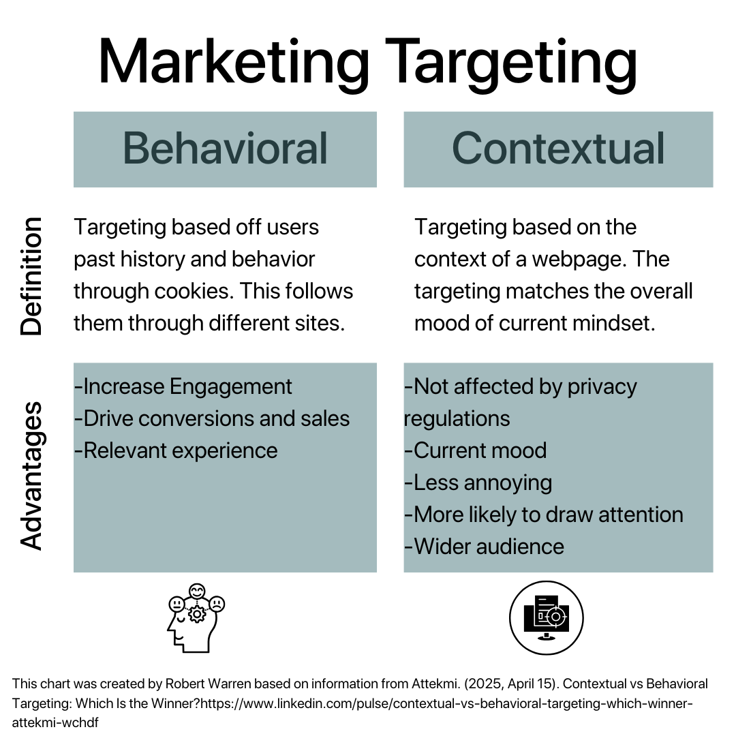
Image Citation [see image, information from: (Attekmi, 2025)]
- Introduction to Kelston Marketing
Kelston Marketing (a.k.a. Kelston, or Kelston Creative,) is a marketing agency for national brands, along with those in DFW, the agency is based in Southlake, Texas will be being used for the case study company in this analysis. While Kelston does not do any paid ad`s this analysis will be exploring opportunities with the advantages/disadvantages of behavioral/contextual targeting.
- Behavioral Analysis
Behavioral targeting in 2025 is highly relevant to marketing. It offers enhanced relevance through cookies making ads more personalized. It is very good for re-marketing as it collects information about consumer behavior and can be spouted back to the customer through emails and/or ad campaigns relevant to things they viewed or interacted with. According to Adobe “ 76% of consumers are more likely to buy from brands that personalize their marketing strategy.” (What Is Behavioral Targeting and Why It’s Important, n.d.) It also helps with improved campaigns, stronger customer relationships, growing an audience and data insights/decisions. (What Is Behavioral Targeting and Why It’s Important, n.d.)
- Contextual Analysis
Contextual targeting, seeing ad`s based on your real-time activity on webpages (not history,) is done to relevant webpages that reflect what your ad is about. Contextual based targeting involves a few things: keywords, categorization and analysis. Through the analysis bids are considered, filters are put to match relevance, then there is a relevance score that is put into consideration. Through all of this it ensures the most relevant, topical and well-paid ad`s have a spot on a webpage that is topical to the ad. AI also plays a role in all of this to help position everything as correct as possible across multiple channels. (Autor, 2025) “These tips and best practices to maximize the effectiveness of your campaigns and optimize your reach:Choose the right targeting approach, Leverage AI and automation for smarter targeting, Optimize ad creative
Prioritize brand safety, Advertise across multiple channels, Use first-party data and Track ad performance.” (Autor, 2025) Another way to be successful at this is through observations of your competitors in these key areas.

- Privacy concerns and ethical implications
Contextual advertising is important in 2025 as Google is planning to let users make an informed choice on cookies. “On July 22, 2024, Google announced that the company is scrapping its plans to phase out the use of third-party cookies in its Chrome browser. Google previously announced plans in 2020 to phase out third-party cookies, a digital advertising tool that tracks consumers’ Internet activity across websites.” (Hunton Andrews Kurth LLP, 2024) “Rather than deprecating third-party cookies, Google has decided to pursue a new user experience in Chrome that “lets people make an informed choice that applies across their web browsing” and enables them to “adjust that choice at any time.” While Google works on this new approach, it will continue to develop and make available the Privacy Sandbox APIs, as well as offer additional privacy controls.” (Hunton Andrews Kurth LLP, 2024) With all the talk of what users can do with cookies contextual advertising remains the safe choice, less worrisome to consumers on their privacy, and less potential problems with privacy laws.
Ethical concerns for consumers can be the amount of data collected, what data is collected and how it is used. Also do users fully understand the information that is being collected from them? Are they being manipulated if they have to agree to terms to use an app or website? Is the information being sold or spread by collecting this information? Also it is important to think about how transparent is the information to the consumer? Most of the issues in this revolve around behavioral targeting where contextual is more aligned with keywords and other AI based tactics. (Targeted Advertising and Manipulation | Digital Ethics and Privacy in Business Class Notes | Fiveable, n.d.)
- Case Study Applications
Through the analysis of this if Kelston were to implement a paid strategy it would be best to a competitive analysis with a look into what other marketing agencies are doing in these areas. It is important to best understand how to position Kelston by looking at how competitors are using contextual and behavioral targeting strategies in their marketing plan. After analysis, it would be good to see buying behaviors of customers through behavioral targeting and reading the cookies. To best ensure a return on investment it may be good to add in some contextual targeting as well. As users are in real-time mindsets it would be best to place relevant ads in areas that they are in. As behavioral is more open to targeting everywhere contextual is more aligned to targeting the right customer. Using Facebook Ad`s would be a good way to find that ideal client by narrowing down the customers based on demographics and the buyer persona. Doing some A/B testing in ad`s would be very important to see which ones works best with minor differences. Continually analyze data and reapproach until eventually getting the best ad at the best time. Behavioral retargeting may also be good to do for customers through targeted email campaign funnels depending where the users are in the marketing funnel.
- Conclusion with recommendations
There is no perfectly right approach. While contextual advertising may be safer as far as privacy goes, sometimes more effective, it would also be a disadvantage to not target behavioral campaigns at all either. The best way to handle deciding which campaigns to do would be based off of audience research and analysis. Looking at competitors is also a very valuable tool for finding marketing placement. This has been the ultimate guide to behavioral and contextual analysis.

Citations:
-Targeted advertising and manipulation | Digital Ethics and Privacy in Business Class Notes | Fiveable. (n.d.). Fiveable. https://library.fiveable.me/digital-ethics-and-privacy-in-business/unit-5/targeted-advertising-manipulation/study-guide/erL4S1ZLPaZRasYN
-Hunton Andrews Kurth LLP. (2024, July 31). Google abandons plans to phase out Third-Party cookies. https://www.hunton.com/privacy-and-information-security-law/google-abandons-plans-to-phase-out-third-party-cookies#:~:text=On%20July%2022%2C%202024%2C%20Google,consumers'%20Internet%20activity%20across%20websites.
-What is behavioral targeting and why it’s important. (n.d.). https://business.adobe.com/blog/basics/behavioral-targeting#:~:text=Retargeting.%20Displaying%20ads%20to%20users%20who%20have,takes%20multiple%20brand%20exposures%20before%20someone%20buys.
-Attekmi. (2025, April 15). Contextual vs Behavioral Targeting: Which Is the Winner? https://www.linkedin.com/pulse/contextual-vs-behavioral-targeting-which-winner-attekmi-wchdf
-Khandelwal, A. (2025, January 9). What is Behavioral Targeting? 4 Important Benefits for Marketers. Blog. https://vwo.com/blog/behavioral-targeting/
-What is Contextual Advertising? How it Works. (2025, April 27). Amazon Ads. https://advertising.amazon.com/library/guides/contextual-advertising
-Smith, S. (2007). Behavioral Targeting Could Change the Game. EContent, 30(1), 22. EBSCO HOST CITATION.
-Open Ai. (2024). ChatGPT (April 25 Version) [Large language model]. Open AI. https://chatgpt.com/share/680bfa81-b7ac-800a-ad24-41822508a663

*Disclaimer Statement: Open AI Deep Learning GPT Explorer was used in this Behavioral and Contextual Targeting Analysis Paper for developing an initial preliminary outline. When prompted with: “Help me come up with a masters level outline of how to tackle the following: Introduction of the two targeting strategies, Analysis of both the behavioral and contextual targeting strategy, Evaluation of privacy concerns and ethical implications, Discussion of practical applications in marketing campaigns for your case study company, Conclusion with recommendations. You are NOT to write the paper for me, I will do that. How I want to approach this is in a unique fashion. I plan to name this 450-675 word paper, "The Ultimate Guide to 2025 Behavioral and Contextual Targeting Strategies," I want to address this analysis in a fashion that hits key points directly indicative of the newest research. Help me come up with an outline for my paper, SEO trending, that can be the best paper out there on a masters level,” Then also fed this information: “1. My reference point is Kelston Marketing in Southlake, TX. Just to be clear again, I will be writing this, I only need a well developed outline. 2. marketing-industry professional masters academic scholar 3 prioritize the most trending and most relevant to 2024-25 4 more traditional, only outline, I am writing this and want to make that clear.” Open Ai helped develop an outline to develop initial thoughts which is being used for this paper. All research and further assessments is original in context. Outline for the academic paper was measured against these sources by Ai: “6 distinct source references noted. Here's a quick tally and recap for clarity: Forbes (AI and Personalization), Forbes (Zero-Party Data), GDPR Local (CPRA 2024 Compliance), ExchangeWire (Contextual Advertising Predictions 2024), Global Market Insights (Contextual Advertising Market Growth)” Additionally, the points covered in the paper may have further sources throughout in-text citations, which also will be reflected at end of paper citations to justify the deeper dig after the initial outline. Please note all of this above dually mentioned as needed. Here is a link to the AI chat for reference.

