Kelston Homepage Analysis with Competitor Comparison

Robert Warren
Digital Marketing M.S., Full Sail University
DMK542-O 01: DIGITAL DESIGN AND USABILITY
Vidal Fonseca
May 11, 2025

Kelston Homepage Analysis with Competitor Comparison

By: Robert Warren

Introduction
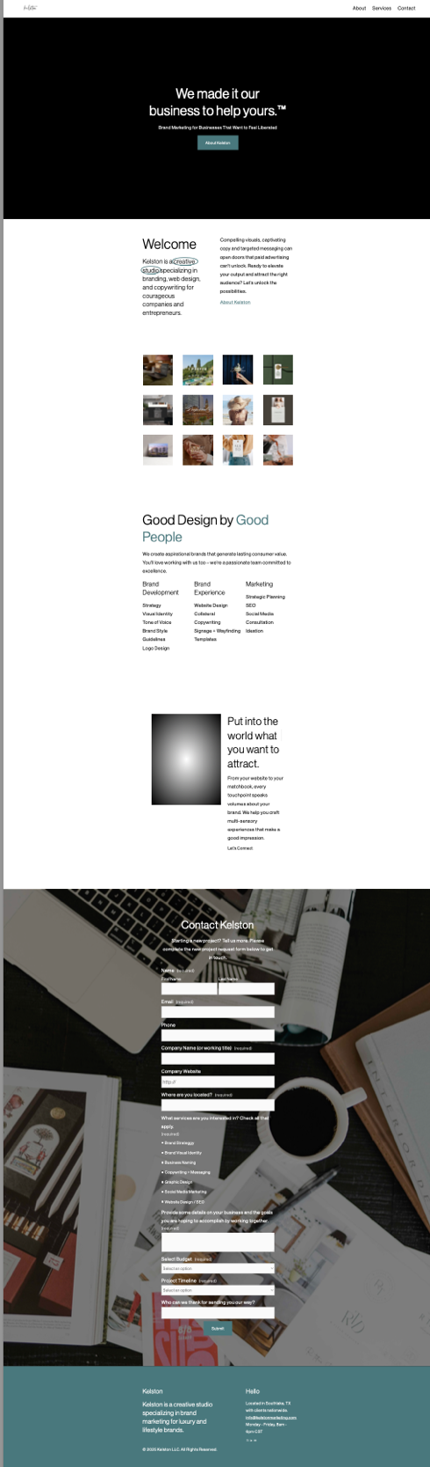
- Website Overview
- URL: https://www.kelstonmarketing.com
- Kelston Marketing is a marketing agency and creative studio based in Southlake, Texas. Kelston’s niche in the market is branding, web design and copywriting. The higher class individual, whether that be a CEO, entrepreneur or brand is the target audience. The individuals for targeting are ages 25 to 40-years-old. The purpose for Kelston is to unlock what paid advertising can`t---“compelling visuals, captivating copy, and targeted messaging,” (Kelston | Marketing and Branding Studio in Southlake, TX, n.d.) by creating “brands that generate lasting consumer value.” (Kelston | Marketing and Branding Studio in Southlake, TX, n.d.)
Kelston Homepage
(Kelston, n.d)

- A brief on the Kelston homepage is the navigation menu on the top is white with the logo in the top left saying “Kelston,” in cursive. There is the sections About, Services and Contact listed at the top. There is a cycling video of elements staying in motion, such as: a lady riding on the back of bike throwing her hands up in the air (like freedom,) a person dancing, water rippling as someone puts their foot in it, a lady walking with a exercise mat, flowers swaying and a person swimming backwards in a pool. The tagline is “We made it our business to help yours,” with a button to click to find out about Kelston.

Kelston Homepage
(Kelston, n.d)

Competitor Analysis

- Competitors Website
- URL: https://chappellroberts.com
- This is a competitor to Kelston because even though Chappel Roberts is based in Tampa, Florida they also target national clients and have more of a niche focus in branding. The brand is in the marketing service industry, also a marketing agency like Kelston. They target more of a lifestyle audience as does Kelston. One thing Chappel Roberts does better than Kelston is they showcase many of their projects on their website. Kelston groups everything together versus that of Chappel Roberts which spreads each individual project out. This is similar to a blog style design. The features Kelston can learn from looking at Chappel Roberts would be showcasing projects blog style, adding a blog, adding a cookie consent pop-up for transparency, perhaps adding the hamburger menu on the navigation to simplify the user experience.
- Specific elements of the homepage that stand out are the introduction video on the forefront. The talk bubble design placed on the rotating video and the simplified messaging of “CREATE_____” (ChappellRoberts, Ad Agency Tampa, Branding, Advertising & Digital Marketing, n.d.) There is also a downward arrow on the video so you know to scroll down. The colors are bold with black, red and white. The navigation is clean. Welcomed in with a video, scroll down to see bold text “Iconic Brands. Bold Strategies.” (ChappellRoberts, Ad Agency Tampa, Branding, Advertising & Digital Marketing, n.d.) Then there is a carousel of images, red outline boxes that say “View the Work,” for many of Chappel Roberts projects. There is a section to see their capabilities (a.k.a. their services,) in grid style. The colors keep the brands main colors of red, black and white. Continue scrolling there is a bold quote, brands Chappel Roberts has worked with, blogs, and the footer with their information. What stands out here is a clean flow with lots of images to make it easy to scroll through the homepage. The grid makes their services stand out as it is much more prominent than being a simple list. According to the Elementor blog “Modular grids are composed of columns as well as rows. They’re often compared to or described as looking like a checkerboard, and can be very effective for presenting many things at once for easy access.” (Gillis, 2024) The quote can help people connect to the brand and seeing the brands they work with can help give some credibility. This is why the flow works so well. When running a speed test on Pingdom for Chappel Roberts homepage it tested with an 80 grade performance with a 24.9 mb page size, 1.10s load time, and 76 requests. (Pingdom Tools, n.d.-c) Kelston in comparison tested at an 75 grade performance, 13.7 mb page size, 1.83s load time and 82 requests. (Pingdom Tools, n.d.-c) With such fast load times on the homepage it is a much more friendly user experience. The red outline around many of the Chappel Roberts buttons makes the CTA very easy to draw attention immediately. (Kuniecki et al., 2015) The hamburger menu for navigation is simple and clean. The biggest thing that could be added for both Chappel Roberts and Kelston`s website is hover over navigation. This would make it easier for the user to understand where their mouse is when looking through the sections.
Chappel Roberts Homepage (Chappel Roberts, n.d.)

Analyze Your Homepage
- Looking at the design of the Kelston homepage is visually appealing and intuitive. Using video on the homepage really makes the content stand out. The quote placed over the intro video is very welcoming and the colors are calm and collected. The navigation is very clean and simple. It may be good to incorporate a hamburger menu that drops down, but as the current navigation bar style is similar to Apple it is a very good choice. The links are clear and logical. It can be a bit misleading with the photo grid however because it looks like it is clickable, however there is nothing to click. The page has room to improve on page load speed. It does appear both clean and working well on mobile where the hamburger does appear. The site reflects properly on both mobile and on Desktop. It loads faster on desktop however. Strengths are the video in the intro, good use of images and a contact form at the end of the homepage. Weaknesses are no highlighted menu items, some items appear clickable when not (such as the product grid.) May want to move the written reviews from the services page to the homepage as well.
- Compared to the competitor the load page does appear slower. There needs to be a blog added especially since Kelston is promoting itself on the SEO end rather than paid. It would also be good to add more of the projects with images to the pages in a blog like style like the competitor does. It may be good to have the hamburger menu both on desktop and on the mobile site. Key differences are load speed, the organization of the site and how services are presented to the consumer. It would be good to incorporate a grid style to catch attention.

Proposed Improvements
- One thing Kelston needs to add is a hamburger menu on the desktop to make the site quicker to navigate. The hamburger menu will simplify the navigation for the user. It will also help keeping everything in one spot. (What Is a Hamburger Menu? | Mailchimp, n.d.) It would also be good to add a blog as it could help drive traffic. The blog could be over marketing and can also help with networking to share the blog. Using the blog for backlinks could be a good tool for SEO. (Parsons, 2021) It would also help to have a grid to showcase the services. Using a grid is more prominent for users to look at.(Nikola, 2023)
- The redesign for the Kelston website would be the same look as current but would have a hamburger menu. It would work to showcase more of Kelstons projects in a blog like style. When scrolling through the website the images would be large and would highlight as you hover over them when scrolling. They would be clickable to further look into each individual project. Then there would be a services grid to showcase each of Kelstons services. You could click through each of the grid images with the icons on them to see the service in more detail. Then there would be a section showing all the brands Kelston worked with. At the end their would be a contact page.
Citations

-ChappellRoberts, Ad Agency Tampa, Branding, Advertising & Digital Marketing. (n.d.). ChappellRoberts | Ad Agency Tampa | Branding, Advertising & Digital Marketing. ChappellRoberts | Ad Agency Tampa | Branding, Advertising & Digital Marketing. https://chappellroberts.com/
-Pingdom tools. (n.d.-d). https://tools.pingdom.com/
-Kelston | Marketing and Branding Studio in Southlake, TX. (n.d.-b). Kelston | Marketing and Branding Studio in Southlake, TX. https://www.kelstonmarketing.com/
- Gillis, O. (2024, August 14). Grid Layouts in Web Design: 6 Rules of Thumb | Elementor. Elementor. https://elementor.com/blog/grid-design/
- Kuniecki, M., Pilarczyk, J., & Wichary, S. (2015). The color red attracts attention in an emotional context. An ERP study. Frontiers in Human Neuroscience, 9. https://doi.org/10.3389/fnhum.2015.00212
- What is a Hamburger Menu? | Mailchimp. (n.d.). Mailchimp. https://mailchimp.com/resources/hamburger-menu/
- Parsons, J. (2021, April 28). Council Post: Eight reasons Blogging is a worthwhile investment for businesses. Forbes. https://www.forbes.com/councils/forbesbusinesscouncil/2021/04/28/eight-reasons-blogging-is-a-worthwhile-investment-for-businesses/
- Nikola. (2023, July 15). The importance of grids in web design: Complete guide - Clio Websites. Clio Websites. https://cliowebsites.com/the-importance-of-grids-in-web-design/

