Competitive Analysis by Robert Warren

In this assignment, you will visit the Meta Ads Library. Please search and choose one active ad from your case study company and one active ad from a competitor of your case study company to complete the below worksheet. If your case study company does not have any active ads, please choose any company that you would like to review that has an active ad in the Meta Ads Library.
 | Paste Screenshot of Ad below for Brand #1- Your Case Study Company | Paste Screenshot of Ad below for Brand #2
*Please note that upon reviewing: case study company: Kelston (a.k.a. Kelston Marketing, Kelston Creative does not have Meta Ad`s nor run PPC Ad`s for its clients. Due to this I will be using the company: The Matchbox Studio based in Dallas, TX as it closely aligns with that of Kelston offering comprehensive brand solutions. As many of the Dallas branding agencies do not seem to be using Meta Ads on their own agencies, I will also be using award-winning Houston based marketing and creative agency: LeadOrigin. | The Matchbox Studio (Branding and Digital Agency in Dallas, TX):  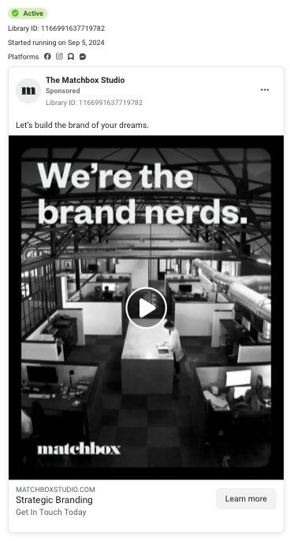 | LeadOrigin (Marketing and Creative Agency in Houston, TX)  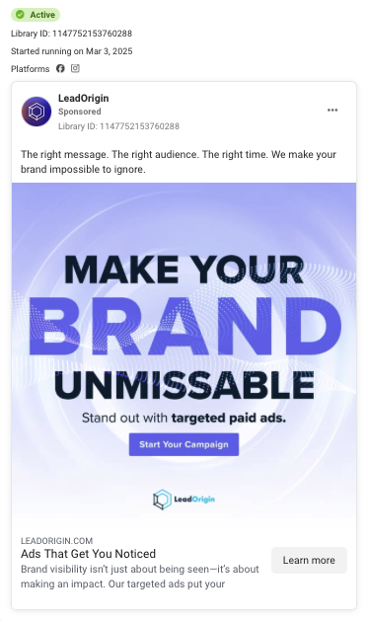
Ad Selection
What format (image, video, carousel) was used for each ad? | Gif; People are just quickly moving around the office in a loop. | Image
On which platforms does this ad appear? | Facebook, Instagram, Messenger, Audience Network (Meaning outside Meta) | Facebook, Instagram
Copy Analysis- Headline
What is the main message of the headline? | Helping consumers build the brand of their dreams. | Making the consumers brand stand out and impossible to ignore.
What specific keywords are incorporated? | Brand (keyword used in the video, headline and in CTA blurb) Strategic | Brand (headline, image, CTA blurb), Message, Audience (headline) paid ads (image) ads (CTA blurb)
How did the brand express its value to the customer? | Saying “nerds,” of branding shows expertise. Black and white photo shows higher sophistication. Moving people quickly around the office shows hustle go-getting attitude, a.k.a hardworking demeanor. The value to the customer being getting a higher value of product (branding,) with knowledgeable hard workers. | “Keeping your brand consistent and strong across different channels can be tough, especially as your business grows and moves into new markets and products.” (Bean et al., 2024) The way the Ad is run purple text with light faded background then purple image of a button shows consistency. The value of standing out in a crowded market is key, the ad makes that their main focus: stand out, be seen.
What words, if any, were used to evoke emotion and what emotion? | “Nerds”- A fun way to describe a sense of sophistication.  “Brand of your Dreams”- Emotional connection of belief, hope, sense of empowerment and friendship towards a goal.  “Strategic,” – Very thought through and well placed, a form of confidence | “YOUR,”-sense of ownership, striking pride  “Impossible to ignore,” – gives a feel of belonging  “Stand out”- lurking towards confidence and pride  “Right…message, audience, time” -targeting perfection and comfort  “Unmissable” – reaching towards the underdog and pulling them towards the front to make them feel like they are fitting in
Copy Analysis- Body of Ad
What specific benefits are highlighted? | Achieving branding dreams, being good at branding (so good help for the consumer), strategic branding for the consumer | Brining attention to a brand, helping the brand be seen and make an impact
How does the copy incorporate social proof (if at all)? | There is a lot of people moving around the office showing the idea of an established bigger agency, with lots of hard-work being done. “Get in touch today,” suggests an urgency to get things done | This ad does not show any key social proof in it. The closest to the social proof is saying “get your brand noticed,” then making the word BRAND stand out.
How does the copy support the headline's message? | The copy supports the headlines message by showing a group of people “working” in a “building,” like they are “working” on “building” dreams through their laptops. Showing “nerds,” working hard reflects the dedication to the goal. | The word BRAND displays RIGHT in front of you,,, “Right…message, audience, time” idea like you cannot miss it. The bold large copy shows the push to get towards the front of peoples attention.
Visual Design
How does the color scheme align with the brand's identity? | This color scheme aligns with the brands identity with a timeless classic look of sophistication of blacks and whites. | This color actually escapes the brands identity. Viewing their website they use more blues with light blue/ dark blue/ white/ black. (LeadOrigin, 2025) Using purple for the ad however can be viewed as a symbol of strength.
How would you describe the text to image ratio of the ad? | 20% Text/80% Image | 60% Text/40% Image
What type of imagery is used (people, products, lifestyle)? | Lifestyle, people moving around an office | Text with plain background
How effective was the imagery to address the overall message of the ad? | Very effective as it is attention grabbing with quick motion, simple message, clear sophistication and very clear CTA | Not very effective, being very text based for an ad, not too attention grabbing, especially since so many users on Facebook can easily make colored blocks with text on them it could get lost easy
Call to Action (CTA)
What specific words are used in the CTA button? | Learn More | Learn More
Are there other places, other than the CTA button, where the CTA was placed? | In the CTA blurb only | On the image itself as what looks like a button that says “start your campaign”
How does the ad create urgency? | Saying “get in touch ‘TODAY,’” the idea is do not wait until tomorrow. | This ad does not have a sense of urgency, more of a sense of pressure with such big font
Where does the CTA link direct users? | Website (matchboxstudio.com) | Website (leadorigin.com)
Are there any secondary CTAs? If so, what are they? | Yes. One that that says “get in touch today,” which directs the user to the same homepage of the website as well | Yes. One that says “LeadOrgin.com” and one that says “Start your Campaign,” both of which lead to the homepage of the website
Target Audience
Who appears to be the primary target audience? | More sophisticated higher end customers that don’t mind spending more to improve their brand. This would be elderly individuals that may not be as good at marketing that are elderly CEO`s, or business owners. | Younger individuals in their late twenties to early thirties. The ad has a more bold pop of color, more of a vibrant digital and tech feel to it. Even the logo of the brand looks more simplified, geometric, and popping in the color.
What psychographic characteristics are being addressed? | The person who may be interested in a product from this ad is likely to be someone from a greater wealth category, such as upper middle class or higher in salary. The person likely values saving money but spending in spurges if the item is of great value. They likely put a high value on ROI and their company. Reasoning for this target is the minimalist design, black/white color and simplicity behind the ad. | The target audience for this ad is likely from a younger generation 25-35 years-of-age with wealth, such as an entrepreneur that needs help in branding. The outlier is also likely to fit into the persona of the buyer, the underdog or someone looking to fit in as they use words in the copy such as “impossible to ignore.”
What specific audience pain points does the ad address? | -Branding confusion (Nerds figuring it out)  -Lost direction (movement in the office)  -Cohesiveness (B&W color) | -Not being seen (“impossible to ignore.”)  -Finding brand confidence (Bold font)  -difficulty with paid ads (“targeted paid ads)
Touch Points
What immediate reaction does the ad aim to generate? | Sophistication and knowledge of the branding marketing industry | Pretty in your face branding capability that can help with paid ads
What actions can the customer take directly from the ad? | Learn more by visiting the website; go to the website to click “Get Started” on the homepage which scrolls straight to the contact form | Learn more by visiting the website; after going there; call straight from the top left section of the navigation bar on the site or click the hamburger to learn more
What specific audience pain points does the ad address? | This Ad is on the awareness stage of the funnel, getting consumers to become aware of the agency. The ad gives hope with words like “dreams,” that the agency can lead the consumer in the directions of correct branding mechanisms, as they appear sophisticated to lead from the B&W persona | This Ad is on the awareness stage on the funnel, solving the problems of how do I get my brand seen and also make an impact? “Brand visibility isn`t just about being seen---it`s about making an impact.”
Overall Effectiveness
What would be the following touch points of the consumer after interacting with this ad until conversion? | Ideally the GIF would autoplay the customer clicks “LEARN MORE”> goes to the websites home > Clicks “GET STARTED” (the main button front and center on the site) It scrolls to the bottom where they fill out a contact form > they fill out the form >then they are reached out by email or phone to get more information and hopefully turn them into a customer > if not, they likely keep getting information from the company that now has their information | Ideally the customer clicks LEARN MORE> then clicks the phone on the top of the navigation bar on their website and receives a call. If not, ideally they scroll to the first button which says “GET STARTED” and gives a contact form to fill out with their information >then they are reached out by email or phone to get more information and hopefully turn them into a customer > if not, they likely keep getting information from the company that now has their information
How well does this ad align with the company's apparent marketing objectives? | Well, very big on getting clients that want branding | Well, very big on getting clients that want branding
What are the strongest elements of the ad? | The black and white minimalist look. It gives it a real sense of class and taste. It adds a real luxury feel. | The bold text saying “BRAND” complimented by the words “we make your brand impossible to ignore
What elements could be improved? | Consistency in font. The brand font is much different from the font in the copy. | Use less sentences. “Text  Keep your text concise and clearly communicate what you’re promoting. Lead with the most important information and keep text to 2-3 short sentences maximum to make sure your full message gets displayed.” (Facebook Ads Best Ways to Advertise Small Businesses, n.d.)
How effectively does this ad stand out from competitor in this analysis? | Very effectively. “Black and white photography sells a vibe. It’s a bold move to forego color, so even this choice in and of itself is a statement. Black and white (B&W) was the original film stock, used to capture some of the most classic and memorable images in history. It reminds us of the richness and historical roots of the medium of photography, as well as the great early modernist photographers who helped elevate the status of photography from a technical practice to an artistic discipline.” (Stocksy, 2023) By using black and white this comes across as a more luxurious brand than that of the competitor. By using a lower text to image ratio the brand has more of a minimalist and focused feel to it. | This competitor stands out in a way that it seems to be targeting paid advertising which it mentions a few times throughout the ad. It has a niche in its target of the outlier or underdog which is a nice touch as well. The branding without any use of lifestyle may come across as less affective however. Also by not following an 80/20 principle the ad may be less effective.
According to this ad, what type of conversion are they trying to achieve? | Awareness, with a learn more button, hopefully gaining more leads that are their ideal target market | Awareness, with a learn more button, hopefully gaining more leads that are their ideal target market
From your evaluation, is the ad designed appropriately to achieve this conversion goal? If so, why. If not, what improvements could be made? | Yes. It has a unique luxurious approach. The hard part is on their website they should have more value to the customer such as a free eBook for instance. | No. This ad should have more lifestyle, less text and a stronger message. The idea is good of targeting the underdog but should have more emotion behind it.
Reflection
Based on this analysis, what insights have you gained in reviewing the advertising strategies of your case study company and one of their competitors? | After doing this assignment I have gained a whole new skill. Looking into Meta Ads library is something that I have never done before. Seeing all the details side by side really helps in analyzing any brand. The value of competitive analysis is very valuable and I can see how completing this assignment is very useful to my degree at Full Sail and my career as a marketer.
What recommendations, if any, would make to improve your case study company’s ability to attract and convert customers through social media advertisements like this one? | I would say look into Facebook Ads Best Ways to Advertise Small Businesses. (n.d.). Meta for Business. They list what works straight on the website. I would also suggest to look into their competitors to see what they are doing. I would further try to do more breakdowns similar to what was created here for the company. I would further suggest to look into the Meta Analytics tools see what are the top rated posts, what has the most views and look at the times people are most active on the platforms. The activity for organic is equally as important with paid social media.

Citations:
Bean, D., Bean, D., & Bean, D. (2024, May 7). A call to action: How to tackle your top 10 marketing pain points. Fleet Management Weekly - Significant Industry News & Developments for the Management of an Automotive Fleet. https://www.fleetmanagementweekly.com/a-call-to-action-how-to-tackle-your-top-10-marketing-pain-points/#:~:text=Brand%20Identity%20Concerns,people%20and%20meeting%20their%20needs.

LeadOrigin. (2025, April 16). LeadOrigin | Digital Marketing & Creative Agency. LeadOrigin. https://leadorigin.com/?fbclid=IwY2xjawJyjHhleHRuA2FlbQIxMAABHpwNyspP4a3hzdrfhRM4PXPtYZR4kCBlMssMEmSnN0qtcjfeSF0lXJPwN3vm_aem_hOXj6kgV0evu0gBsv8izhw

How to use psychographics in Marketing + examples. (2024b, February 16). https://www.hotjar.com/blog/psychographics-in-marketing/#5-psychographic-characteristics

Oestreicher, G. (2025b, January 20). How to see and analyze your competitors’ Facebook ads. Metricool. https://metricool.com/competitor-facebook-ads/

Facebook Ads Best Ways to Advertise Small Businesses. (n.d.). Meta for Business. https://www.facebook.com/business/small-business/advertise/facebook-ads-tips?content_id=YAvwvDmp3OKQagl&ref=sem_smb&utm_term=dsa-1633293535562&gclid=Cj0KCQjwtpLABhC7ARIsALBOCVpMYdtH9c8x2wnEQud54yiiZ8a4Fi1C2X6iKygWUScoXlpbVbHBHwMaAs6nEALw_wcB&gad_source=1&gbraid=0AAAAACr-yC9MqrNztaHdBOTvZGflIMrG7

Stocksy. (2023, May 29). Create iconic campaigns with Black & White stock photos. Stocksy Ideas. https://www.stocksy.com/ideas/black-and-white-photography-campaigns/

